MERIWETHER PLACE COMMUNITY ASSOCIATION, INC
APPLICATION FOR MODIFICATION(S)

Date: Click or tap to enter a date.
Name: Click or tap here to enter text.
Lot Number & Address: Click or tap here to enter text.
Best Contact Number: Click or tap here to enter text.
Email: Click or tap here to enter text.
Preapproved Items that Do Not Need to be Submitted for Consideration:

● Addition of annuals to existing beds
● Re-arranging of existing plant material in existing beds
● Up to 3 flower pots and/or 3 hanging baskets
● Replacing pine straw in existing beds with brown or black mulch
● Deck stain: Covered Bridge (SW3508), Spice Chest (SW3513), Hawthorne (SW3518).
● Storm door: must be full view glass with black or white metal frame.
● Standard window screens
● Portable basketball goals do not require approval but must be kept close to the house except when in use and are not permitted on the streets or cul-de-sacs in the Community at any time.

All other modifications require written approval. Please refer to the Declaration of Covenants, Conditions, Restrictions and Easements for specifics before completing this application. Upon receipt, the complete signed application and supporting documents will be forwarded to the Declarant for review. Please allow up to forty-five (45) days as outlined in the Declaration for a decision to be reached on your application. You will receive written notification of the Declarant’s decision. Per section 6.2 of the Declaration, if construction does not begin within 12 months of approval, such approval will be deemed withdrawn.

☐ LANDSCAPING: Please include photos or drawings of the landscape area including a diagram and plant list for the new installation.

☐ TREE REMOVAL: Please include a photo and survey showing tree location. If you are replacing the trees, please note the type of tree you plan to use for replacement and the location if different.

☐ Lawn Ornaments: Please include photos or drawings of statuary, fountains or other decorative items and desired placement.

☐ RECREATIONAL EQUIPMENT: Please include the following supporting documentation.
- Photo of the equipment.
- Drawing or photo showing where the equipment will be placed in relation to the home.
- Playset must be positioned directly behind the home unless prohibited by topography.

☐ PERMANENT BASKETBALL GOAL:
1- Drawing or photo showing where the goal will be placed in relation to the home.
2- Post must be painted black; and the backboard clear. No goal may be attached to the exterior of the house.

☐ REPAINTING: Please include paint manufacturer, type & color along with color paint samples indicating where the color will be used (i.e., body, trim, shutter, front door, siding, garage doors, gutters, etc.).

☐ ROOFING: Please include the manufacturer type and color of the roofing material. Please supply a photo of or a web link to the shingle color you wish to use. Please do not remit actual roofing shingles.
☐ FENCES: Please include lot survey showing property lines and desired fence placement in relation to the house.

Click or tap here to enter text. (Initial) to confirm compliance with all fence requirements below.

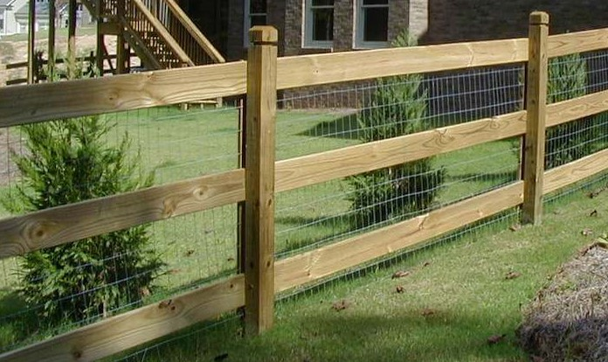

General Fencing Requirements. Fences must be substantially similar in material and style to the fence depicted above with an optional wire backing and adhere to the following conditions:

  - Stained with a clear natural stain.

  - All fences shall be kept in good repair including regular, periodic staining.
  - The finished side of the fence must face out (support rails facing owner’s property).
  - Fencing shall be erected only in the rear yard and shall not extend any closer to the public street, located in front of the residence, than the rear one third of the residence.
  - Fences shall be located on the property lines unless a drainage, sanitary sewer, utility or access easement, buffer or some other consideration prevents fence from being located on a property line.
  - Corner Lots shall be deemed to have two (2) front property lines. As such, no fence shall encroach beyond the building setback line on the side of either street.
  - Fence/wire backing must be installed 2 inches above ground and properly maintained so that leaves and debris do not collect impeding water flow. Impeding water flow may subject Owner to fines, penalties and remediation costs assessed by the association as well as state and local authorities.
  - All fences are required to have a gate.
Fences may not be installed within undisturbed buffers, sanitary sewer or utility easements. Drainage easements may also have additional restrictions.

☐ Hot Tub & Inground Pools: Please provide all supporting documentation:
- A photo or rendering of desired pool/tub. (Note: hot tub must have a locking lid)
- A drawing showing placement of pool/spa in relation to the house.
- Detailed landscaping plan showing screening material and placement.

☐ ACCESSORY STRUCTURES: Please include the following.

- Photo of the accessory structure along with dimensions and details of the foundation, construction materials and colors for the planned structure with lot survey showing placement in relation to the home and lot lines.

☐ Trash Receptacle Enclosure Specifications:
● Dimensions - 6'Lx3'Wx4'H
● Material - Pressure treated pine with 2x4 posts & dogeared top.
● Finish - Painted to match siding.
● Location - 3 feet back from front corner.
● Screening - Shrubs to be planted in front of enclosure for screening.
☐ Storage shed requirements:
● Material – Must be made of wood. No metal or plastic/resin products considered.
● Finish - Painted to match siding.
● Roof – shingles matching roof of home.
● Location - immediately and directly behind the home due to aesthetic considerations.
● May not be placed within undisturbed buffer, sanitary sewer, utility or drainage easements.

Please refer to Section 7.31 of the declaration for additional requirements and restrictions.
Corner lots are subject to additional restrictions & may not accommodate an accessory structure.

☐ STRUCTURAL ADDITION/MODIFICATION: Please include the following documentation:
- Survey showing property lines.
- Detailed drawing/plans showing the dimensions and final look of the project.
- City/County building permits.
- Detailed information on material used, paint manufacturer, color number and paint chip samples.
- Roofing shingles - email color scans or links to manufacturer’s website.
Additional Notes: Click or tap here to enter text.
PROJECT START DATE: Click or tap to enter a date. ESTIMATED COMPLETION: Click or tap to enter a date.

For your protection, contact the proper city/county authority for permit requirements before making any modification.

Click or tap here to enter text. (Initial) I understand and agree that no work on the modification requested herein shall commence until I receive written approval. I represent and warrant that the requested modifications strictly conform to the Declaration of Covenants, Conditions, Restrictions and Easements for the association. I further understand and agree that as the property owner, I am responsible for complying with all city/county regulations.

Click or tap here to enter text. (Initial) I understand and agree that I am solely responsible for determining my property lines and may not rely on existing stakes or statements from neighbors or Starlight personnel.

(SIGNATURE REQUIRED)

_____________________________________________________________ _________________
SIGNATURE (S) OF PROPERTY OWNER (S): DATE

_____________________________________________________________ _________________
SIGNATURE (S) OF PROPERTY OWNER (S): DATE

Please submit completed application and supporting documentation to: bree@atlantacommunityservices.com

Bree Kanzelmeyer, CAM
Community Association Manager
Atlanta Community Services, Inc.
2144 Buford Highway • Suite 110 • Buford, GA 30518
Phone: 770-904-5270 Direct: 678-730-0973
http://www.atlantacommunityservices.com

**********************************************************************************************************************
TO BE COMPLETED BY DECLARANT/ARC: Received: ____________ Reviewed: ____________
Authorized Signature: _________________________________________
☐ Approved as submitted ☐ Conditionally Approved ☐ Disapproved
Comments: _________________________________________________________________________
___________________________________________________________________________________

